Raspberry Pi Setup Documentation

Step 1: Make sure you have all the hardware required 2

Step 2: Configuring YouTube for Streaming 3

Setting up YouTube 3

Putting your stream on VirtualScope 3

Getting your RTMP link 3

`Getting your YouTube channel link 3

Step 3: Setting up the microSD card 4

Step 4: Setting up Raspberry Pi and its corresponding hardware 5

Step 5: Setting Raspberry Pi Operating System 5

Enable the camera 5

Step 6: Setting up Internet Connection 5

Step 7: Update, upgrade, and install the necessary connecting software 6

Running your stream on the Raspberry Pi 7

Put everything together 7

## Step 1: Make sure you have all the hardware required

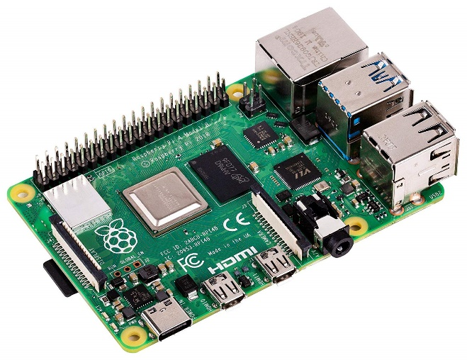Hardware (existing):

Microscope

Hardware to mount (3D print):

1. Camera Housing (2 pieces)
2. Lens attachment piece

Hardware (to buy):

1. Raspberry Pi 4 Model B
2. Raspberry Pi case (with open section)
3. Raspberry Pi charger
4. Raspberry Pi camera
5. Raspberry Pi fan
6. Raspberry Pi heatsinks
7. Raspberry Pi HDMI adapter
8. MicroSD card (at least 8GB)

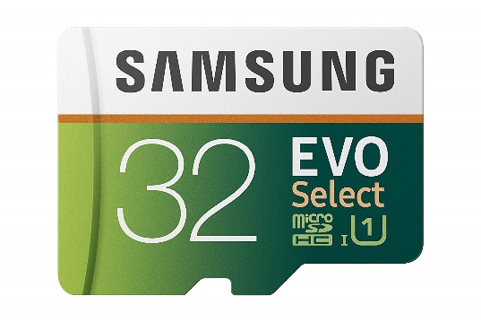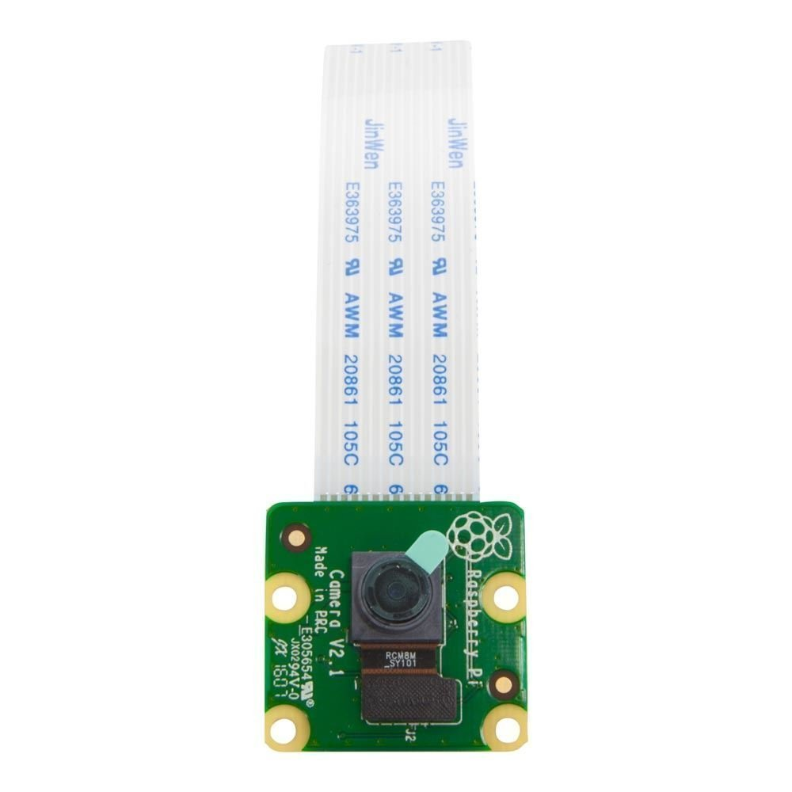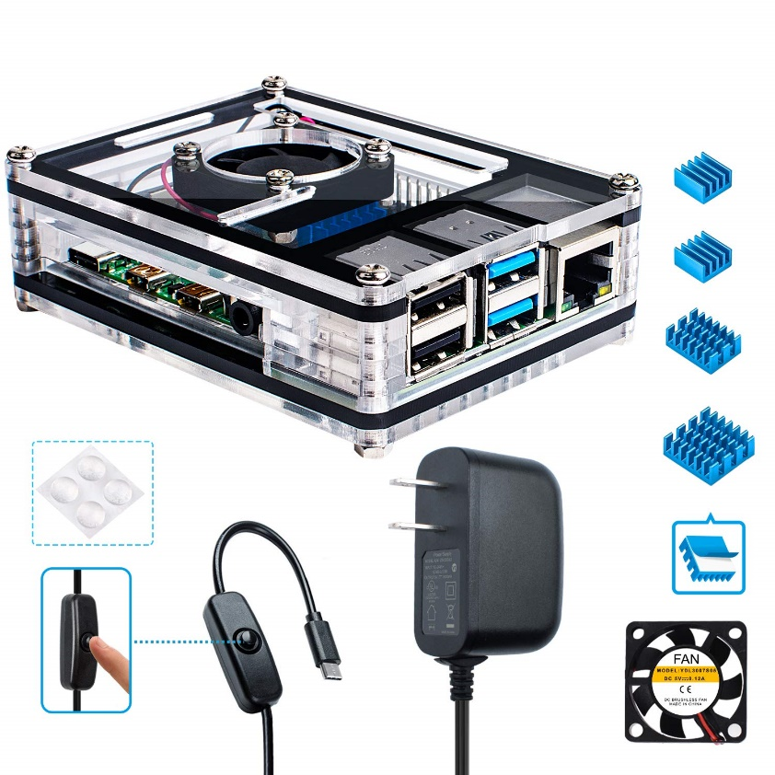

## Step 2: Configuring YouTube for Streaming

#### Setting up YouTube

1. Create a YouTube account on http://youtube.com.
2. Log into your YouTube account.
3. Go to the Creator Studio page.
4. Open the Features section.
5. Scroll down the Features panel and click "Enable.
6. Verify your identity.
7. Accept the terms and conditions.
8. Set the details of your live stream.
9. Click the "Go Live Now" button on the lower right corner of the page.
10. This will allow you to live stream on your channel, but it will take 24 hours to activate.

#### Putting your stream on VirtualScope

Once live streaming is activated for your channel, you’ll need to log into your YouTube account to get the RTMP Streaming link for your microscope and the channel ID.

##### Getting your RTMP link

1. Click your User Profile Icon.
2. Click on the YouTube Studio button.
3. Click on Creator Studio Classic on the left side panel.
4. Click skip.
5. On the left side panel, find and click on the Live Streaming tab.
6. Scroll down to the bottom and find the Encoder Setup section.
7. Copy the RTMP Server URL (example: rtmp://a.rtmp.youtube.com/live2).
8. Press the Reveal button and copy the key.

The format needed for the VirtualScope microscope configuration is the server url followed by a forward slash, followed by the key:

(example: rtmp://a.rtmp.youtube.com/live2/woisufoisuoflsdjfl)

Put this link where it says “YouTube RTMP Stream Link (For Raspberry Pi)”

##### Getting your YouTube channel link

You’ll need to get the embed URL for your YouTube live stream. The embed URL for a channel's live stream is:

https://www.youtube.com/embed/live_stream?channel=CHANNEL_ID

You can find your CHANNEL_ID at <https://www.youtube.com/account_advanced>

Insert this link where it says YouTube link on your microscope configuration page to embed the video on the experiment page.

## Step 3: Setting up the microSD card

This step will have you install the Noobs operating system onto the microSD card so it can be used in the Raspberry Pi.

1. Open microSD card and insert into computer.
2. Go to <https://www.raspberrypi.org/downloads/noobs/> and download Noobs zip file.
3. Go to <https://www.raspberrypi.org/help/noobs-setup/2/> and follow the directions.
   1. When download is finished extract the files from the zip.
   2. Go to <https://www.sdcard.org/downloads/formatter/> and download the SD Formatter 4.0 for either Windows/Mac.
   3. Install SD Formatter 4.0 and then run it.
   4. In SD Formatter 4.0, format microSD card.
   5. Move the extracted Noobs files into the now formatted microSD card. You need to have the files inside the Noobs folder inside the microSD card, NOT
   6. Remove microSD card safely.
4. Remove microSD card safely.

## Step 4: Setting up Raspberry Pi and its corresponding hardware

1. Insert microSD card into Rasberry Pi slot and set aside.
2. Follow the instructions of the Raspberry Pi case (included with the case).
   1. Before closing the top/lid attach the Raspberry Pi, feed the camera strip through the slot and connect it to the Pi. When connecting the camera, lift the black strip of insert on the pi device, insert strip, then secure black strip.
3. Remove film on camera.
4. Attached Micro HDMI adapter to HDMI cord connected to a display monitor.
5. Insert the HDMI micro adapter end to the micro slot on the raspberry pi.
6. Insert the power chord into the power slot on the raspberry pi.
7. Once completed, you will see your monitor populate a message pop up window.

## Step 5: Setting Raspberry Pi Operating System

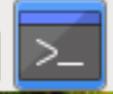1. Click install for Noobs. (This could take awhile).

2. After installation is complete you will see a message that will say “OS(es) installed successfully” then click OK..

3. The raspberry pi will restart

4. see gallery picture to complete this section

• You will see a welcome message pop up window. Click Next.

• Set country window will populate. Set country, language, time zone to your location. Check “Use English language” and check “Use US keyboard. Press Next.

• The Change Password window will populate. Set new password. Click next.

• The Set up screen window will populate. Check the “This screen shows a black border around the desktop. Click Next.

• The Select Wi-Fi Network window will populate. Click Skip.

• The Update Software window will populate. Click Skip.

• The Setup complete window will populate. Click Restart.

#### Enable the camera

* Go click on the raspberry on the top left corner. From the drop down select preferences, then go to the Raspberry Pi Configuration. Go to Interfaces tab, then click Enable in camera. You will be prompted to restart, click yes.

## Step 6: Setting up Internet Connection

1. A hardwired ethernet connection is best. Plug in an ethernet cord into the raspberry pi. Make sure that the ethernet port has a working internet connection.

## Step 7: Update, upgrade, and install the necessary connecting software

1. Go to the terminal application in the top left hand corner
2. Install ffmpeg (software that allows video streaming) by entering the following command:

sudo apt get install ffmpeg

1. Install the update for the Noobs operating system by entering the following command:

sudo apt-get update

1. Install the upgrade for the Noobs operating system by entering the following command:

sudo apt-get upgrade

If there is a prompt to ask if you want to continue, select yes. There will be many modules preparing and unpacking packages. This may take quite some time. Some packages present a log of their changes, if a prompt appears asking if you want to quit, press q. (google “linux change log, press q to quit” for an example photo).

An information window will show up saying that upgrade has been installed.

1. To connect to the database you install a Mysql connector type by entering the following command:

sudo pip install mysql-connector-python==8.0.11

1. You want to download the virtualscope python file and saving it to your raspberry pi. To do this, enter the following command:

sudo wget -O virtualscope.py https://raw.githubusercontent.com/huntress13/TeamPuma-VirtualScope/master/Raspberry/virtualscope.py

This should be all on one same line. You should get a message in the terminal that infers that the file virtualscope.py has been saved.

1. Type the letters “ls” to show a list of files in your current directory. You should see the file you just downloaded virtualscope.py
2. Make sure that you are in home/pi/
3. You want to create a folder to put in the streaming photos. To do this you need to make a folder. Make a new folder/directory by entering the command:

sudo mkdir MicroscopeImages

You should now be ready to run the VirtualScope script on your Raspberry Pi

## Running your stream on the Raspberry Pi

To run the python file, enter the command:

sudo python virtualscope.py microscope_name

where microcscope_name is the name of your microscope. (i.e. microscope1) After you click enter, you should immediately be streaming and uploading photos to the website according to your defined interval.

## Put everything together

* Turn on the microscope and put in a subject slide
* focus the slide to what you want
* Fit the hardware pieces to the camera
* Turn on the raspberry pi
* Mount the camera piece to the eyepiece.